**Supplementary figures.**

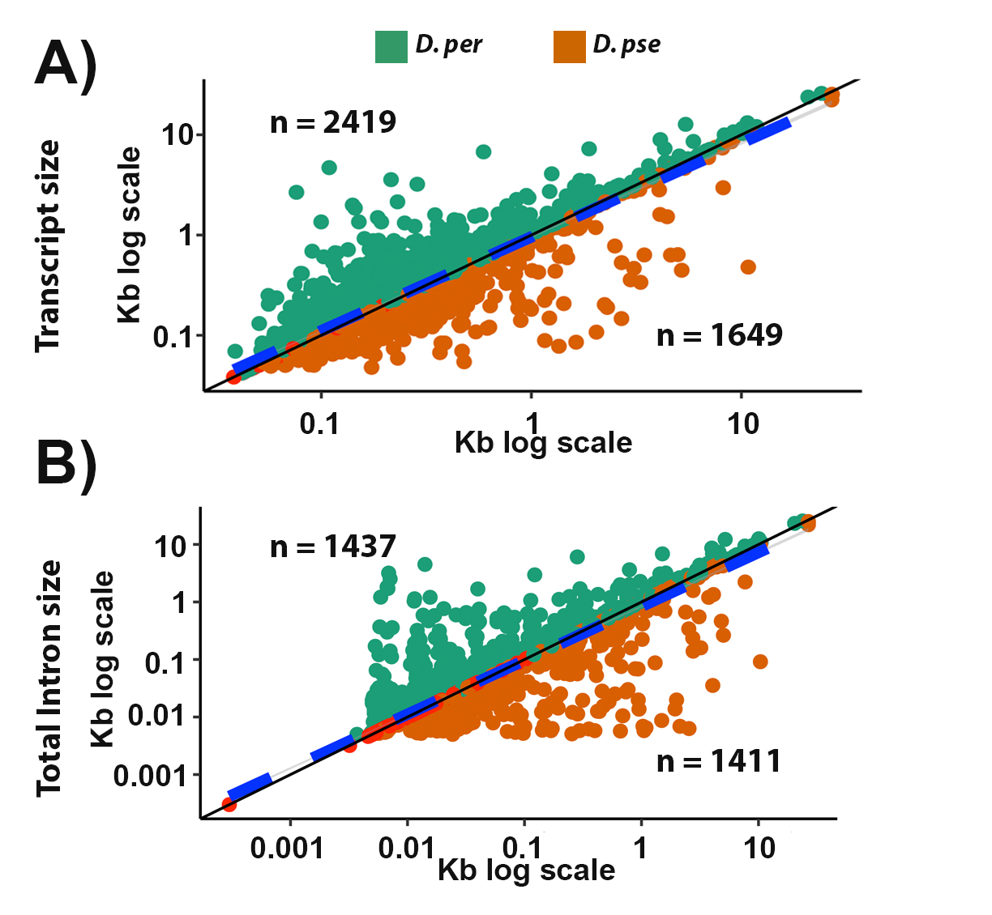

**Figure S1.** Correlation plots for transcript size (A) and intron size (B) between *D. pseudoobscura* and *D. persimilis* for the 4,613 orthologous genes with the same aminoacid length. ‘n’ depicts the number of genes with larger transcript size (A) or larger intron size (B) for each species (above or below the curve). Black solid line represents the 1:1 expectation between species; blue dashed line depicts the implemented LM: R2 = 0.8694; Intercept = 0.2358; Slope = 0.9363 (A) and R2 = 0.8756; Intercept = 0.1736; Slope = 0.9372 (B).

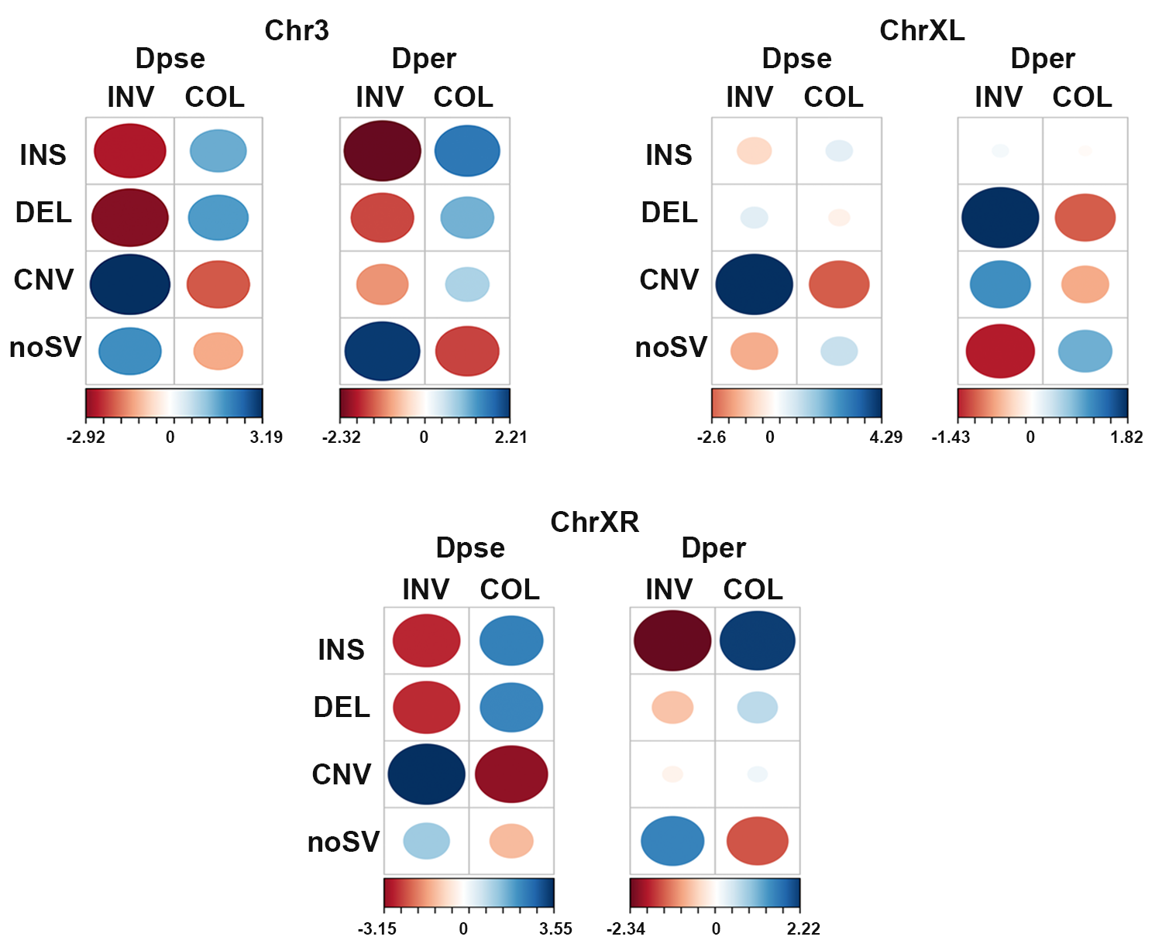

**Figure S2**. Correspondence analysis showing the association between genes (including the 10kb upstream region) and SVs, for chromosomes 3, XL and XR. Circle sizes depict the number of genes, and color depicts correlation values (bottom of contingency table). INS: insertions; DEL: deletions; CNV: copy-number variants; noSV: genes not associated with SVs.

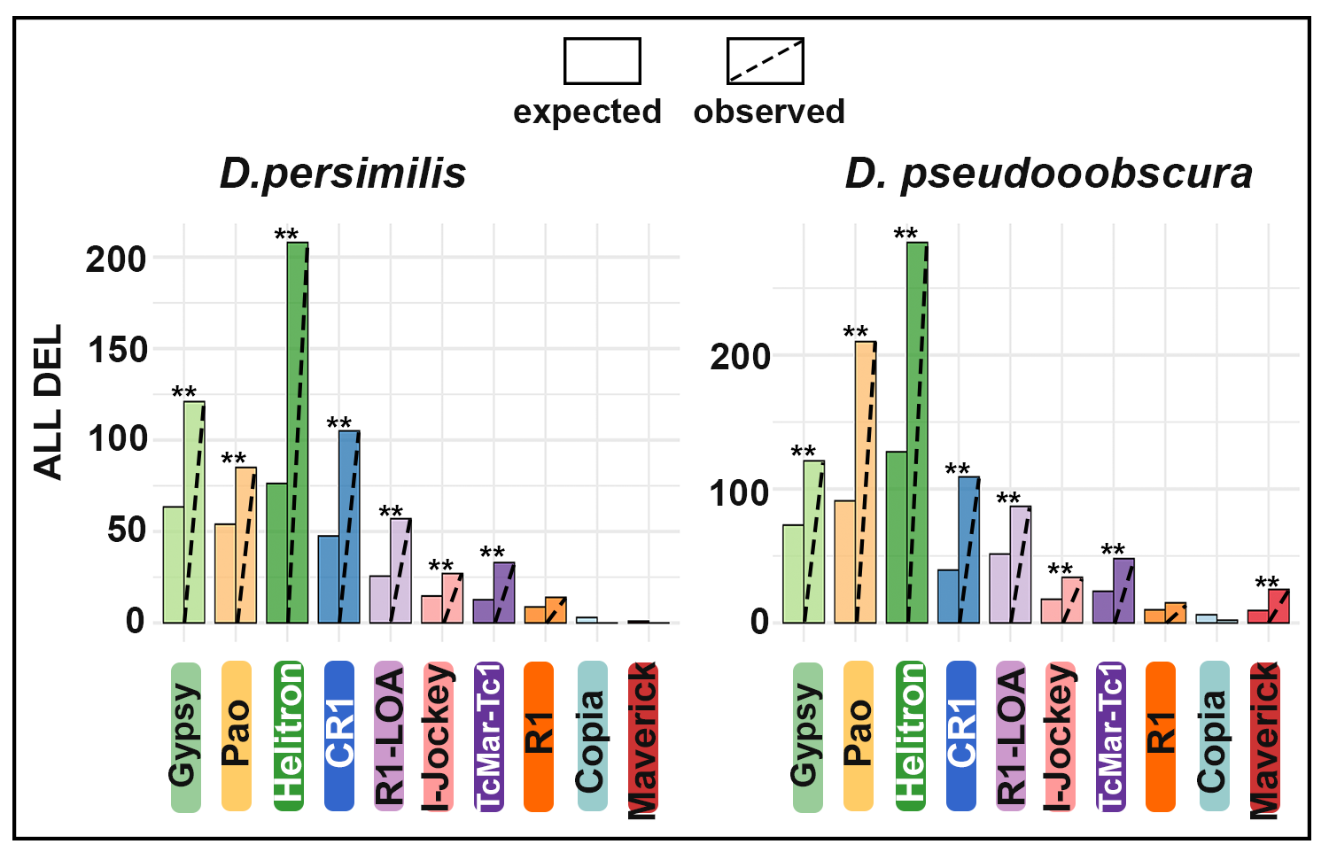

**Figure S3**. Permutation analysis of DEL overlapping TE annotations; ** p < 0.01 significant difference between observed and expected counts.

**Figure S4.** Expression levels of the 10 most abundant TE families in both *D. pseudoobscura* and *D. persimilis* (x-axis). Colors depict four developmental stages and average read counts are represented in log scale (y-axis). Up graph show read counts using *D. pseudoobscura* genome as a reference and bottom graph is the reciprocal analysis using *D. persimilis* genome as a reference.

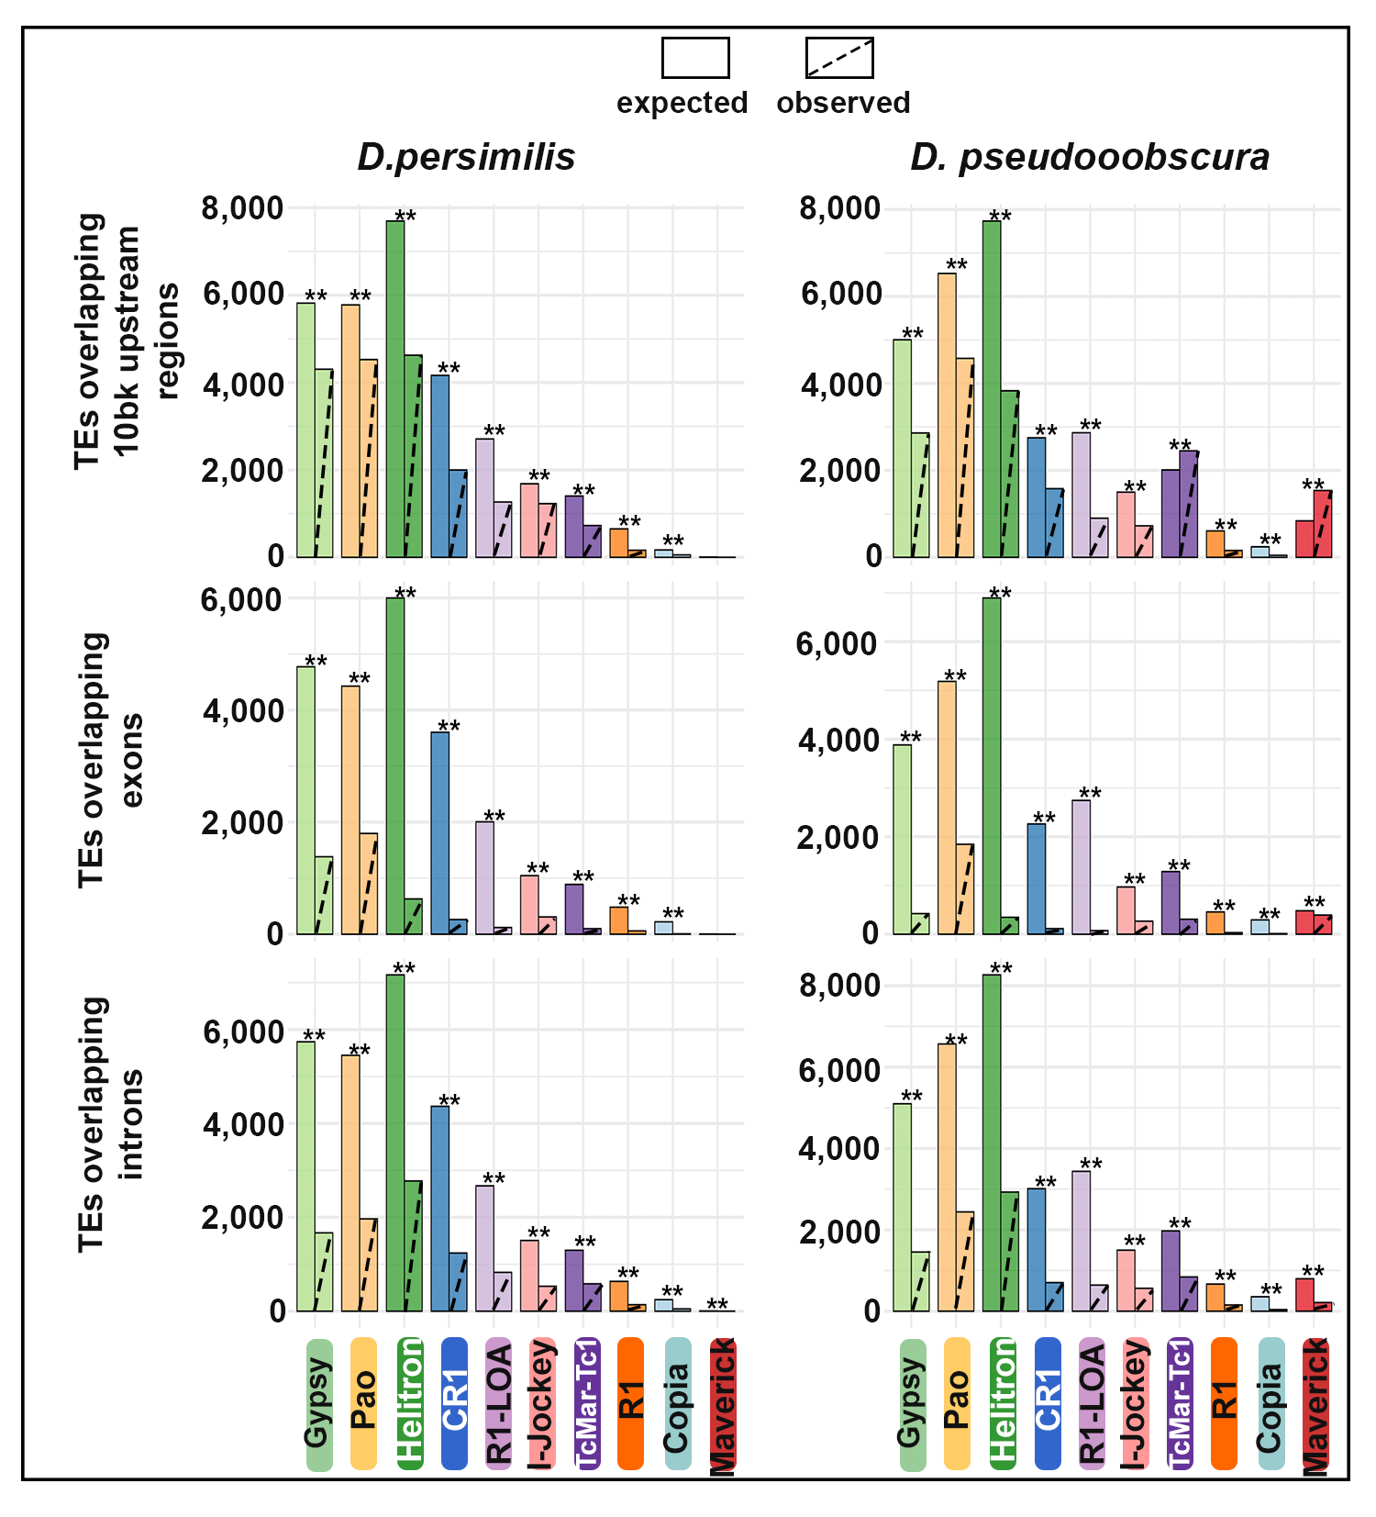

**Figure S5.** Permutation analysis of TEs overlapping annotated gene regions; ** p < 0.01 significant difference between observed and expected counts.

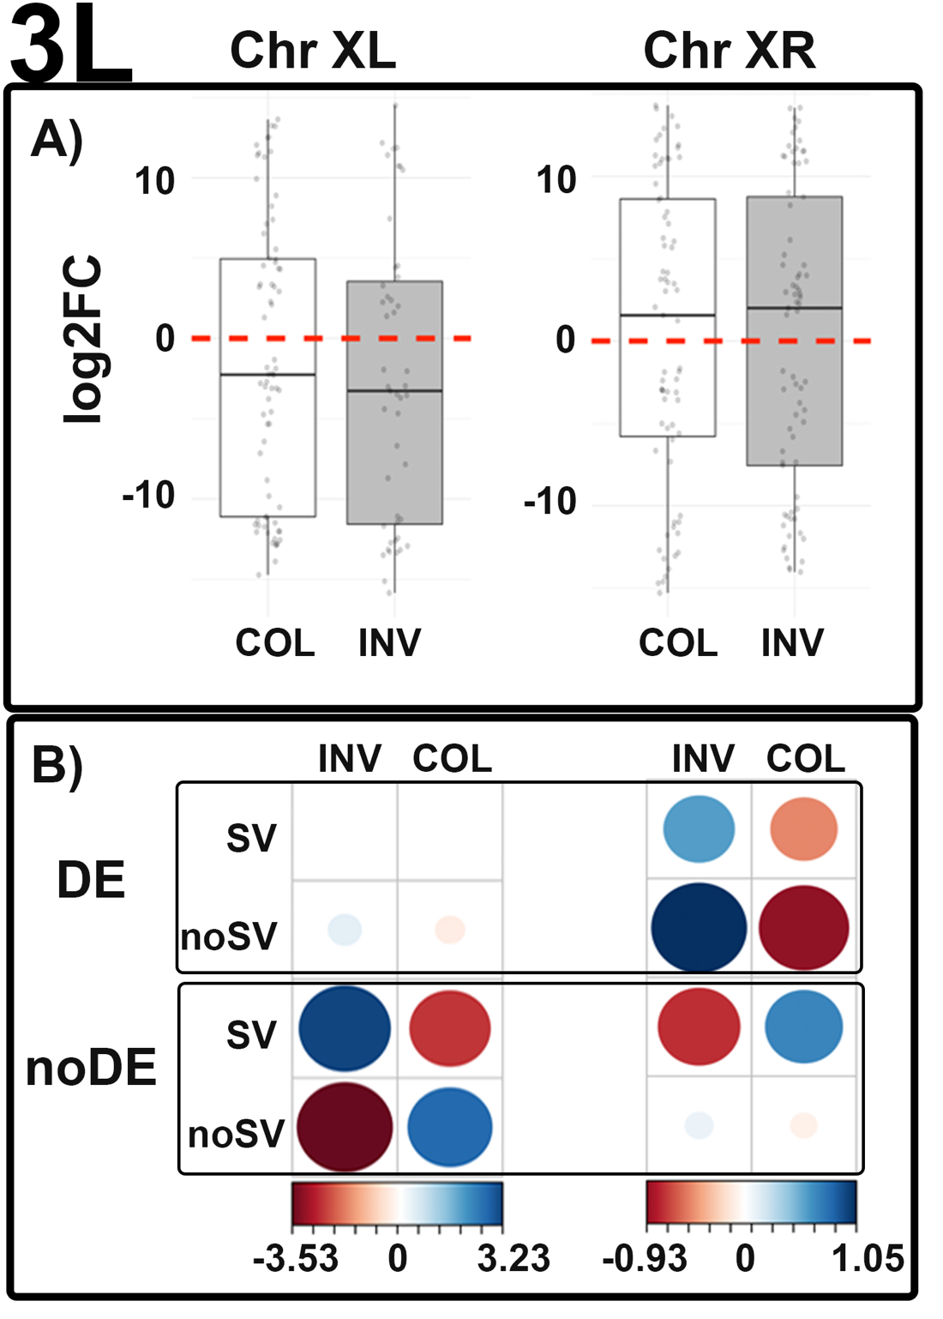  
**Figure S6.** Gene expression and its association with SVs for chromosomes with inversion differences between *D. pseudoobscura* and *D. persimilis* for the 3L developmental stage. A) Log2 fold change values for differentially expressed genes comparing the co-linear and inverted regions; > 0 higher expression in *D. pseudoobscura*; < 0 higher expression in *D. persimilis*. B) Correspondence analysis showing the association of genes differentially expressed (DE) or not (noDE) with the presence of absence of SVs in the 3L stage; circle sizes depict number of genes, and color depicts correlation values (contribution of the overall Chi-square statistic).

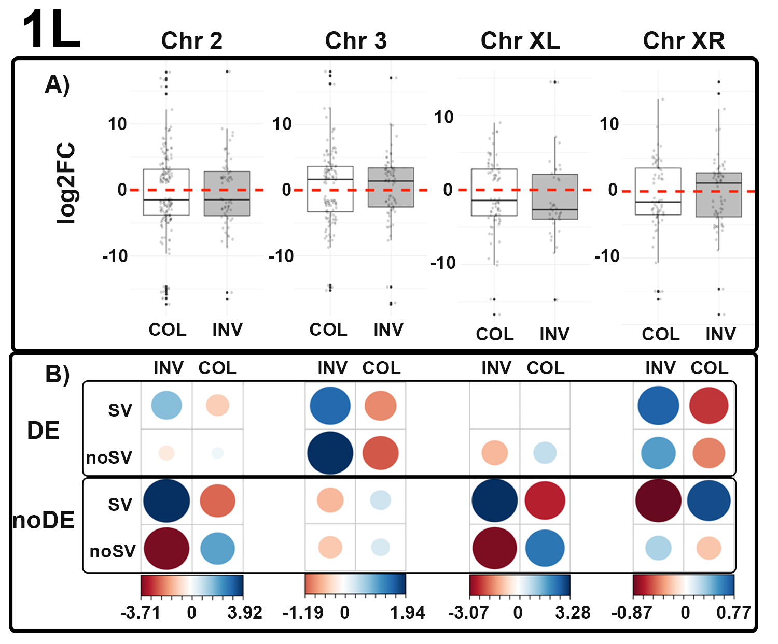

**Figure S7.** Gene expression and its association with SVs for chromosomes with inversion differences between *D. pseudoobscura* and *D. persimilis* for the 1L developmental stage. A) Log2 fold change values for differentially expressed genes comparing the co-linear and inverted regions; > 0 higher expression in *D. pseudoobscura*; < 0 higher expression in *D. persimilis*. B) Correspondence analysis showing the association of genes differentially expressed (DE) or not (noDE) with the presence of absence of SVs in the 1L stage; circle sizes depict number of genes, and color depicts correlation values (contribution of the overall Chi-square statistic).

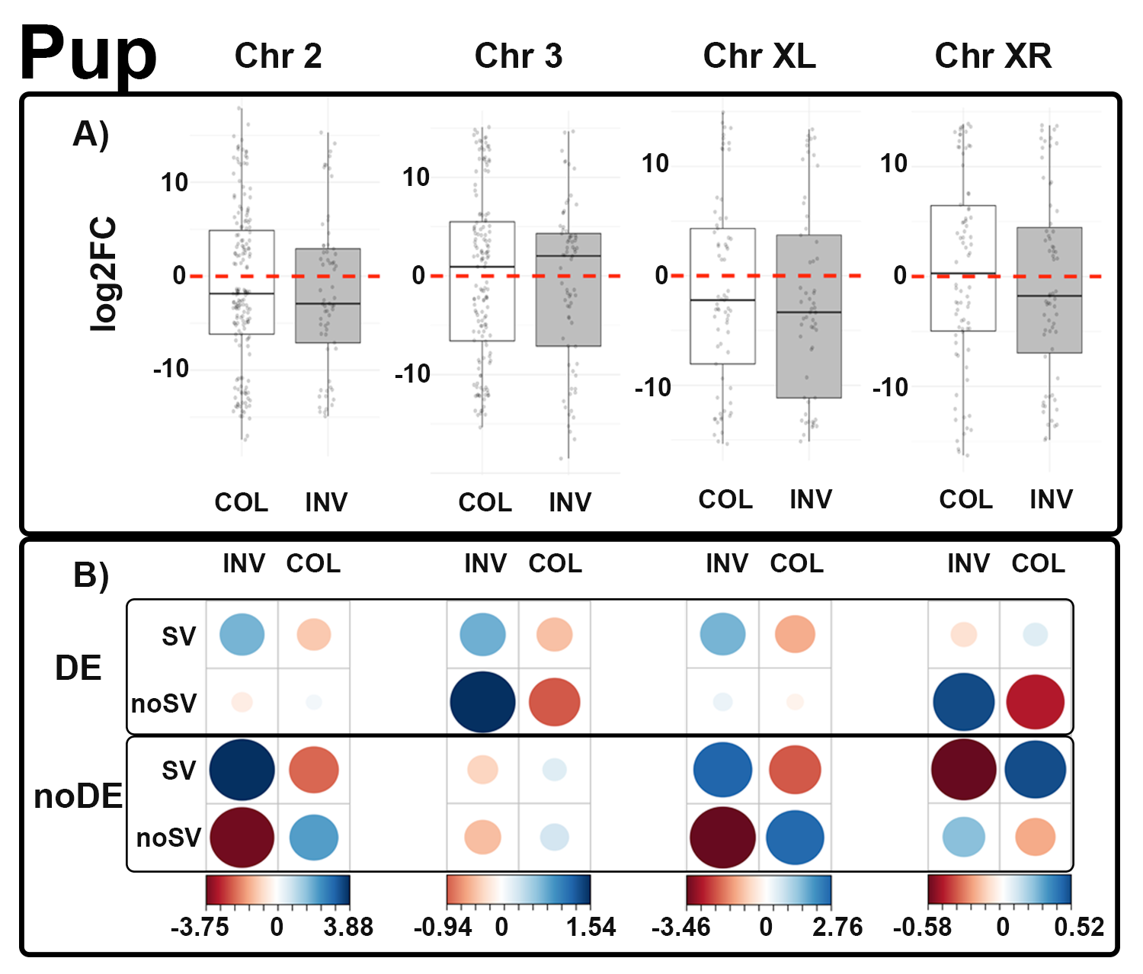

**Figure S8.** Gene expression and its association with SVs for chromosomes with inversion differences between *D. pseudoobscura* and *D. persimilis* for the Pup developmental stage. A) Log2 fold change values for differentially expressed genes comparing the co-linear and inverted regions; > 0 higher expression in *D. pseudoobscura*; < 0 higher expression in *D. persimilis*. B) Correspondence analysis showing the association of genes differentially expressed (DE) or not (noDE) with the presence of absence of SVs in the Pup stage; circle sizes depict number of genes, and color depicts correlation values (contribution of the overall Chi-square statistic).

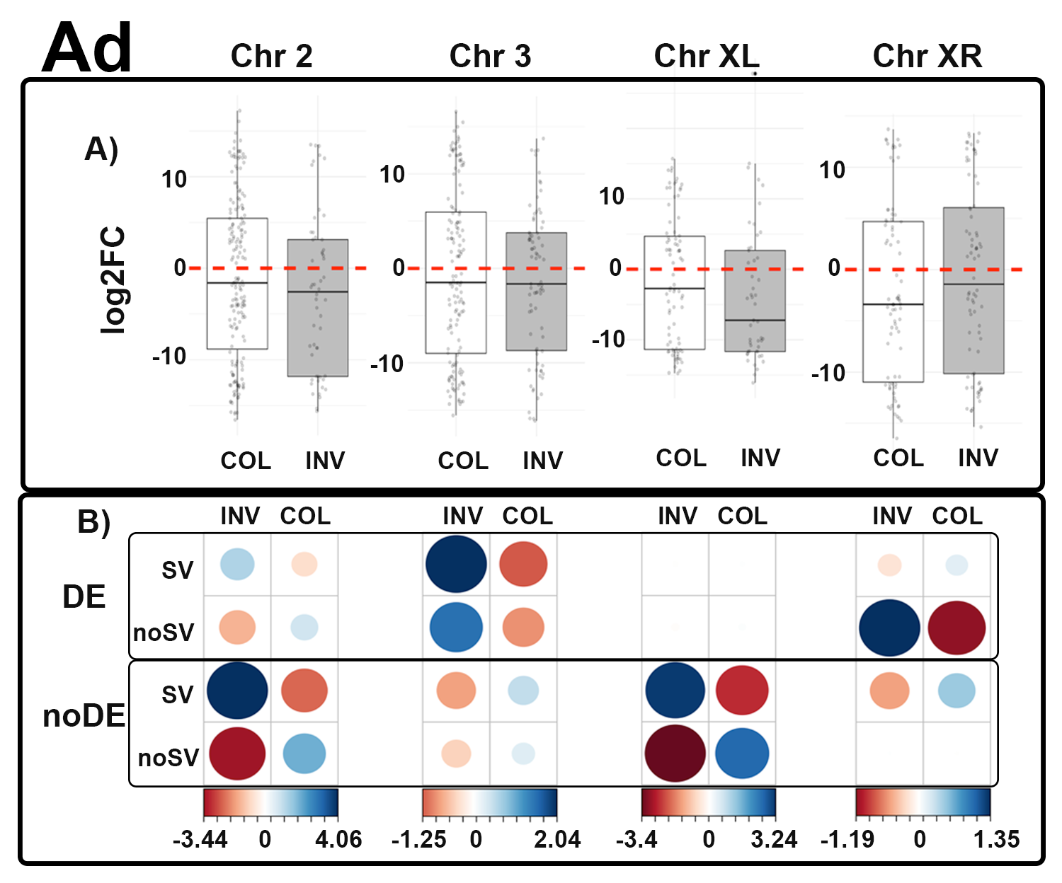

**Figure S9.** Gene expression and its association with SVs for chromosomes with inversion differences between *D. pseudoobscura* and *D. persimilis* for the Ad developmental stage. A) Log2 fold change values for differentially expressed genes comparing the co-linear and inverted regions; > 0 higher expression in *D. pseudoobscura*; < 0 higher expression in *D. persimilis*. B) Correspondence analysis showing the association of genes differentially expressed (DE) or not (noDE) with the presence of absence of SVs in the 3L stage; circle sizes depict number of genes, and color depicts correlation values (contribution of the overall Chi-square statistic).

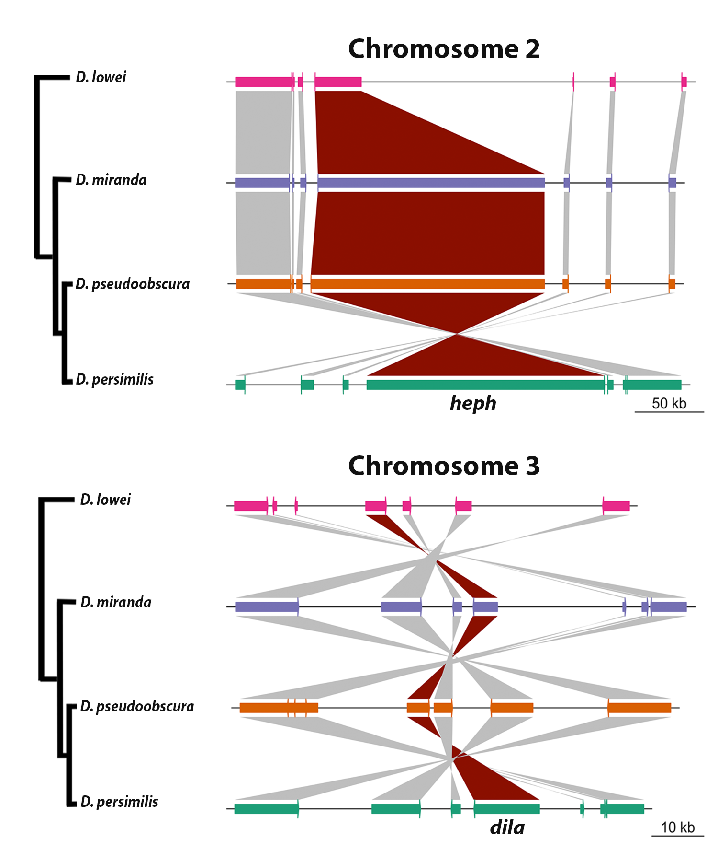

**Figure S10.** Genomic context (up) of the *heph* and *dila* (darked ribbon) genes showing conservation on the order of neighbor genes both up and downstream across the *D. pseudoobscura* subgroup.

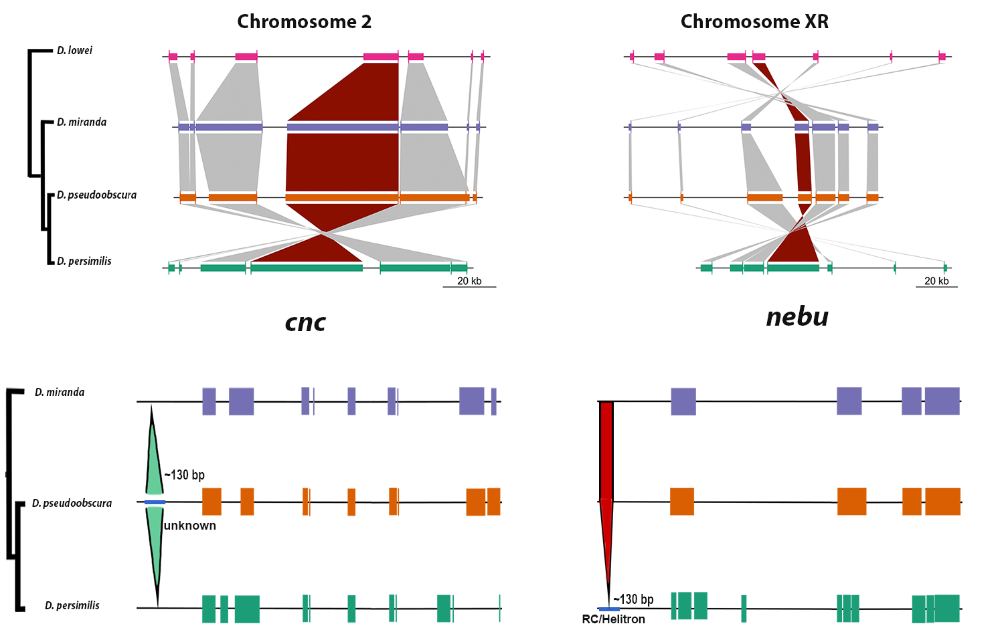

**Figure S11.** Genomic context (up) of the *cnc* and *nebu* (darked ribbon) genes showing conservation on the order of neighbor genes both up and downstream across the *D. pseudoobscura* subgroup. The bottom figures show the *cnc* and *nebu* gene models and the position of an INS occurring in *D. pseudoobscura* and a DEL occurring in *D. persimilis*, both in the 10kb-upstream region.

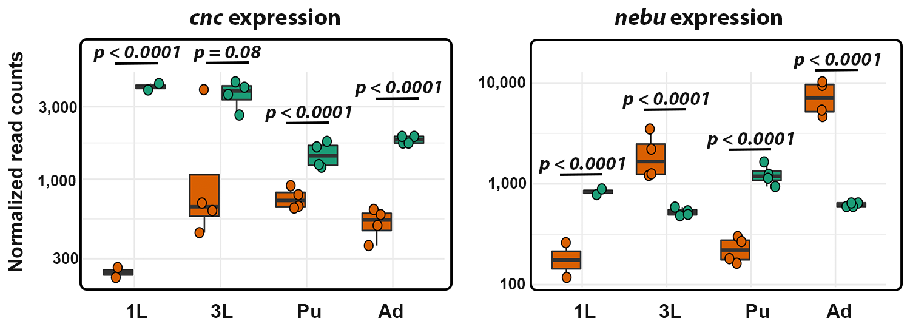

**Figure S12.** Boxplots showing the normalized read counts in log scale for *cnc* and *nebu* over four developmental stages: 1L: first instar larvae, 3L: third instar larvae, Pup: Pupae, Ad: Adult, between *D. pseudoobscura* (orange) and *D. persimilis* (green).



**Figure S13.** Dot plot for the final assemblies of *D. pseudoobscura* and *D. persimilis*. Purple dots represent co-linear blocks and light blue dots represent inversions in the corresponding chromosomes. REF(x-axis): *D. pseudoobscura*; QRY(y-axis): *D. persimilis*.



**Figure S14.** Dot plot comparing our *D. pseudoobscura* assembly versus the *D. pseudoobscura* -MV225, assembly from (Liao, Zhang, Chakraborty, & Emerson, 2021). Purple dots represent co-linear blocks and light blue dots represent inversions in the corresponding chromosomes. REF(x-axis): *D. pseudoobscura* – MV225; QRY(y-axis): *D. pseudoobscura* – this study.



**Figure S15.** Dot plot comparing our *D. persimilis* assembly versus the *D. pseudoobscura* -MV225, assembly from (Liao et al., 2021). Purple dots represent co-linear blocks and light blue dots represent inversions in the corresponding chromosomes. REF(x-axis): *D. pseudoobscura* – MV225; QRY(y-axis): *D. persimilis* – this study.



**Figure S16.** Dot plot comparing our *D. pseudoobscura* assembly versus the *D. pseudoobscura* -MV225, assembly from FlyBase (Thurmond et al., 2019). Purple dots represent co-linear blocks and light blue dots represent inversions in the corresponding chromosomes. REF(x-axis): *D. pseudoobscura* – FlyBase; QRY(y-axis): *D. pseudoobscura* – this study.



**Figure S17.** Dot plot comparing our *D. persimilis* assembly versus the *D. pseudoobscura* -MV225, assembly from FlyBase. Purple dots represent co-linear blocks and light blue dots represent inversions in the corresponding chromosomes. REF(x-axis): *D. pseudoobscura* – FlyBase; QRY(y-axis): *D. persimilis* – this study.

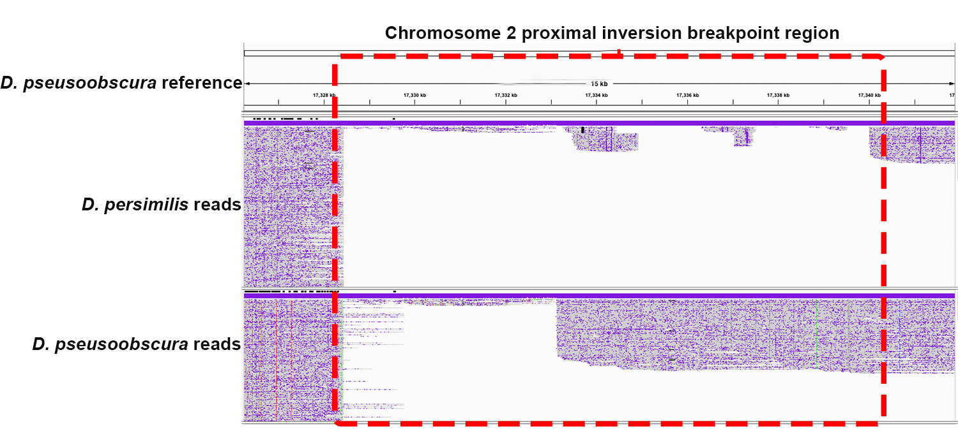

**Figure S18.** Chromosome 2 proximal inversion breakpoint of *D. pseudoobscura.* Dashed red square indicates the location of the inversion breakpoint region identified in this study.

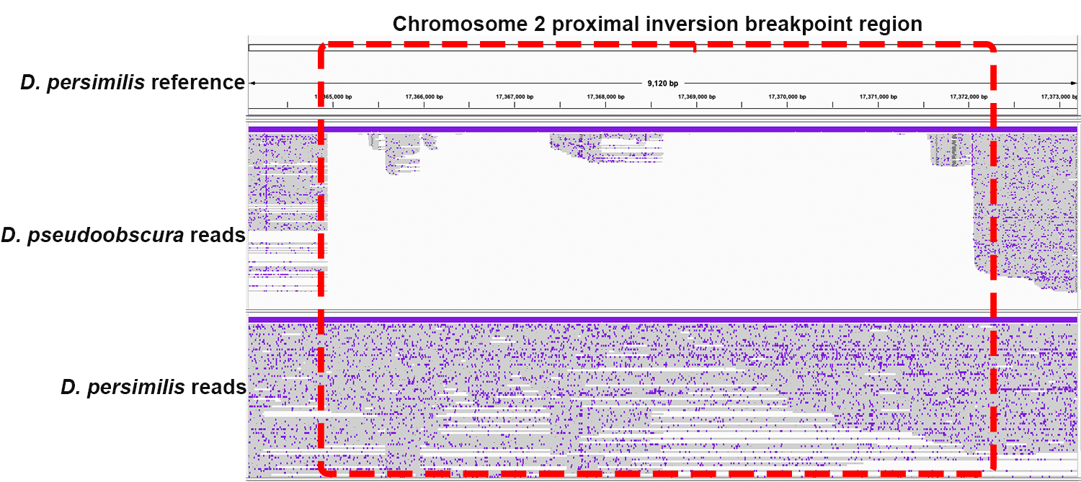

**Figure S19.** Chromosome 2 distal inversion breakpoint of *D. pseudoobscura.* Dashed red square indicates the location of the inversion breakpoint region identified in this study.

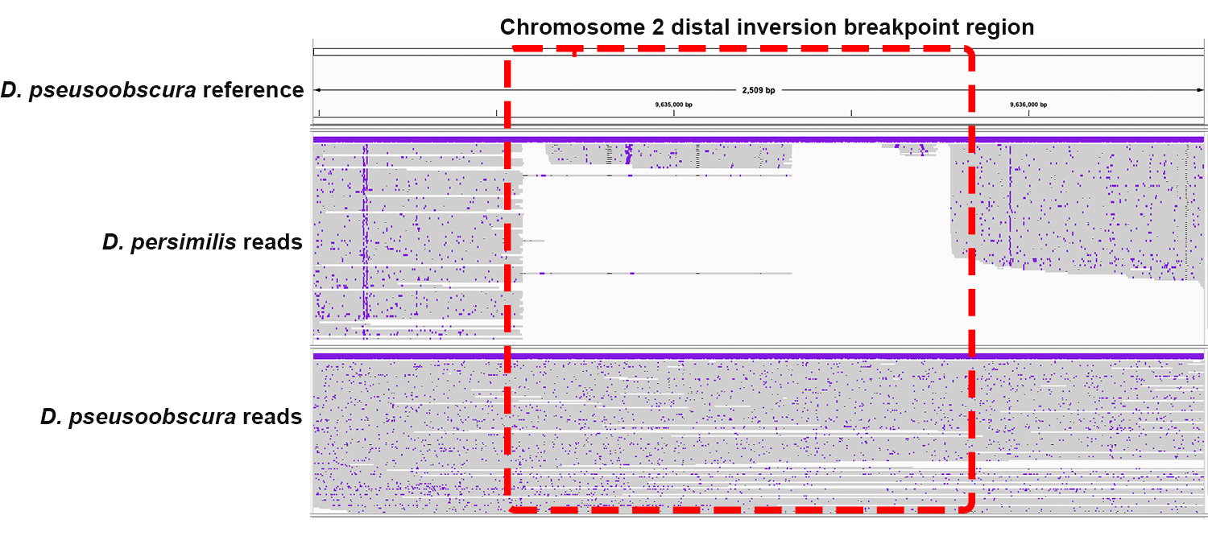

**Figure S20.** Chromosome 2 proximal inversion breakpoint of *D. pseudoobscura.* Dashed red square indicates the location of the inversion breakpoint region identified in this study.

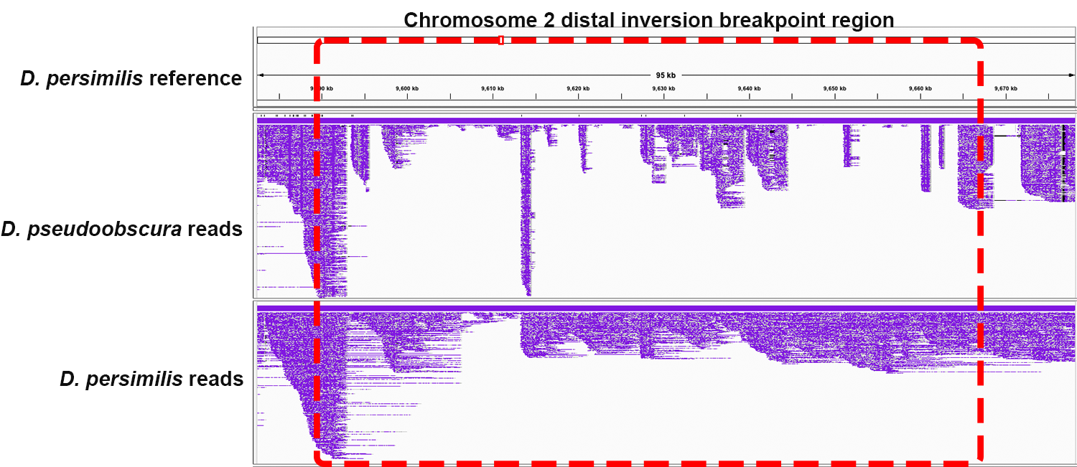

**Figure S21.** Chromosome 2 distal inversion breakpoint of *D. persimilis.* Dashed red square indicates the location of the inversion breakpoint region identified in this study

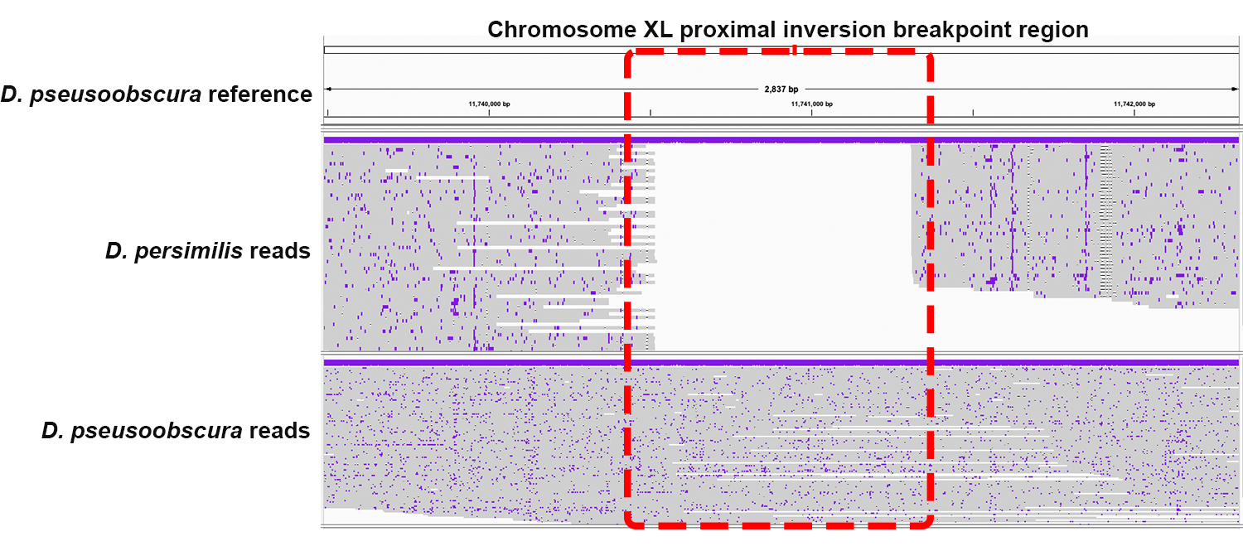

**Figure S22.** Chromosome XL proximal inversion breakpoint of *D. pseudoobscura.* Dashed red square indicates the location of the inversion breakpoint region identified in this study

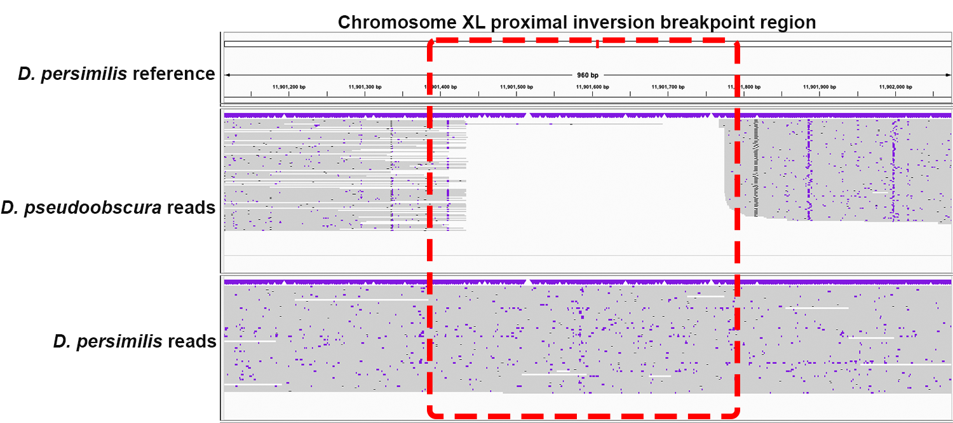

**Figure S23.** Chromosome XL proximal inversion breakpoint of *D. persimilis.* Dashed red square indicates the location of the inversion breakpoint region identified in this study.

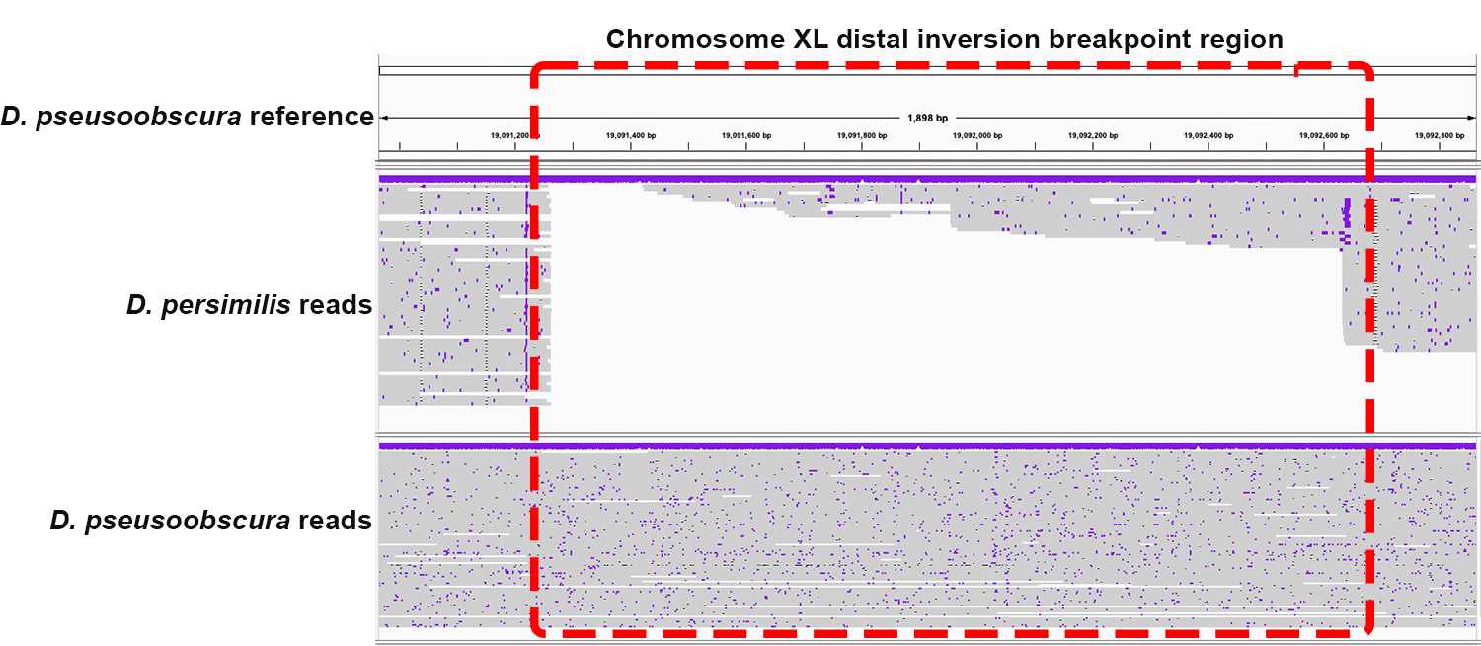

**Figure S24.** Chromosome XL distal inversion breakpoint of *D. pseudoobscura.* Dashed red square indicates the location of the inversion breakpoint region identified in this study.

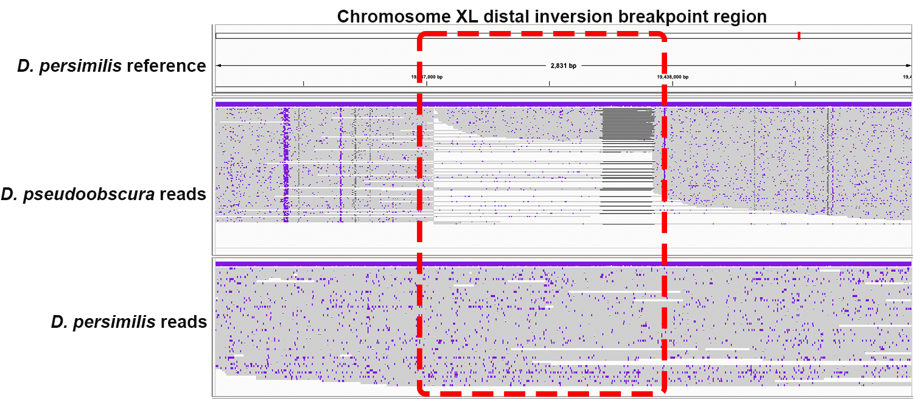

**Figure S25.** Chromosome XL distal inversion breakpoint of *D. persimilis.* Dashed red square indicates the location of the inversion breakpoint region identified in this study.

**References.**

Liao, Y., Zhang, X. W., Chakraborty, M., & Emerson, J. J. (2021). Topologically associating domains and their role in the evolution of genome structure and function in Drosophila. *Genome Research, 31*(3), 397-410. doi:10.1101/gr.266130.120

Thurmond, J., Goodman, J. L., Strelets, V. B., Attrill, H., Gramates, L. S., Marygold, S. J., . . . FlyBase, C. (2019). FlyBase 2.0: the next generation. *Nucleic Acids Res, 47*(D1), D759-D765. doi:10.1093/nar/gky1003